Chapter One | Introduction

1.1 Identification

“Scan in Travel” is an Android application that uses the built-in camera of a mobile phone to capture the image of a Chinese word, converts that image into text, and translates it into English. Tourists can understand the meaning of the word in text and listen to how it is pronounced in Chinese. “Scan in Travel” can use the built-in camera to capture the image of a Location name, and provide the maps and route of the place to help users get to the location. Moreover, the application can also provide Favorites and Word book to help tourists record their trip and help them easily return those Locations.
This project plan is the document for planning, scheduling activities and evaluating overall of the project so that the project will complete as successfully as possible in spite of all risks. The project plan is the plan before start project and when project start, project plan is used to tracking and control project follow the plan.

1.2 Project Scope

“Scan in Travel” is a mobile application which using Android OS. This application can help users solve the language problems during their travel in China. Users can get the meaning of a Chinese word by scanning it with the built-in camera of their mobile phone. And users can also get the map and route if the scanned name is the name of a Location in China. What is more, “Scan in Travel” can also help users remember where they have been. Users can record the attractive places into their Favorites.
The main features of “Scan in Travel” will be following:
Translation system
Users can translate Chinese words and Location names into English by scanning them with the built-in camera of their mobile phone. After viewing the English translation of a word, users can also select the text-to-speech function to listen to the pronunciation of the Chinese word.
Favorites system
Users can save Chinese words and their English translation to their own Word book. If users scan a Location name, they can also save the Location with its name, pictures, geometry information (i.e. latitude and longitude), and descriptions into their Favorites. Users can take the picture of the Location and write down their own description for it. Moreover, users can sort and search words in their own Word book and Locations in their Favorites.
Map system
Users can keep their own map of every Location that they saved. The system lets users see every saved Location on a map, and check the details of each Location. Besides, users can scan a Location name and find where it is located on a map. The system will guide users to get to the Location by providing a route on a map.

1.3 Document Overview
The purpose of the “Scan in Travel” Project Plan is to guide the project team members during the development of the project.
Progress Report Ⅰ：
Feature #1 Translation system
1.1: Users can scan Chinese words and Location names by using built-in camera.
1.2: Users can view the explanation (i.e. meaning, pronunciation) of the scanned word in English.
1.3: Users can select Text-to-Speech to get the Chinese pronunciation of the word.
1.4: Users can lock/unlock the screen which displays the text of the scanned word. (When locked, the scanning function will be disabled temporarily and the screen will keep the scanned image on display.)

Progress Report Ⅱ：
Feature #2 Map system
2.1: Users can view the Location on the map if the scanned word is the name of a Location.
2.2: Users can view all Locations from their own Favorites on the map.
2.3: Users can view the map that shows the route from the current position to a Location stored in Favorites.
2.4: Users can view the map that shows the route from the current position to the Location whose name is scanned.

Feature #3 Favorites system (Part 1)
3.1: Users can add the scanned Location with its name, pictures, geometry information (i.e. latitude and longitude), and descriptions into their Favorites.
3.2: Users can delete a Location from their own Favorites.
3.3: Users can view the Location information with name, pictures, geometry information (i.e. latitude and longitude), and descriptions in their Favorites.
3.4: Users can sort the Locations in Favorites by district name.
3.5: Users can sort the Locations in Favorites by date they are added.
3.6: Users can search Locations by keyword in their Favorites.
3.7: Users can select Text-To-Speech to get the pronunciation of the Location name in their Favorites.

Progress Report Ⅲ:
Feature #3 Favorites system (Part 2)
3.8: Users can add the scanned words into their own Word book.
3.9: Users can delete a word from their own Word book.
3.10: Users can view the Chinese words and related information in their own Word book.
3.11: Users can sort the words in their Word book by date when they are added.
3.12: Users can sort the words in their Word book alphabetically.
3.13: Users can search Chinese words in the Word book by their meaning in English.
3.14: Users can select Text-To-Speech to get the pronunciation of a Chinese word in their Word book.
1.4 Objectives
1. To develop a mobile application that helps tourists who come to visit China with the followings:
-- Lowering the language barriers when they travel in China.
-- Getting the translation of the Chinese word in an easier way by scanning the word rather than typing.
-- Getting the map of the location in China easily by scanning the Location name.
-- Remembering and learning Chinese words.
-- Reaching the destination more quickly.
-- Remembering and recalling the Locations where they have been to.

2. To develop a mobile application that allows users to use the services anytime while traveling in China as long as they are connected to the Internet (Some functions are also supported offline. E.g. Word Book).

3. To offer the features that provide more convenience to tourists compared to using other guide books or dictionaries:
-- Providing a dictionary, a map, and a personal note in one application, which helps tourists travel light.
-- Reducing manual text input.
-- Saving time for searching information.

1.5 Work Products to be Develop
1.5.1 Deliverable
No. | Deliverables/Release | Media | Copies | Date
1 | Project Proposal  · Scan in Travel _Project Proposal_V1.0  · Scan in Travel _Project Proposal_V1.1 | Document  Document | 3  1 | 04-03-2014  18-03-2014
2

1.6 Acronyms and Definitions
1.6.1 Acronyms
OCR Optical Character Recognition
VSE Very Small Entity
SMS Short Message Service
OS Operating System
SDK Software Development Kit
JDK Java Development Kit
API Application Programming Interface
JSON JavaScript Object Notation
XML Extensible Markup Language

1.6.1 Definitions

Chapter Two | Infrastructure
2.1 Software Development Life Cycle
Incremental delivery is a combination of waterfall model and evolutionary development. It is a method for developing a system through repeated cycles in smaller portions (increments), allowing developers to make use of what was learned during the previous parts in the development, and also a quick comment back from users when exposing one increment to them. Key steps in the process start with a simple implementation of a subset of the software requirements and incrementally enhance the evolving versions until the full system is implemented. Specification, development, and validation activities are interleaved with rapid feedback cross activities.
Scan in Travel uses Incremental Delivery Process for development. Because in the development, there are several progresses to separate the whole system. Each progress is considered as an increment to complete a sub-set of the system functionality. The allocation of services to increments depends on the service priority which is identified by customers, with the highest-priority services implemented and delivered first. System is delivered in a number of increments. Each delivery is usable and working but has only partial functionality, and furthermore, each delivery is the same as previous one but with some new functionality. The final delivery is the full system. We use Incremental Delivery Process to fulfill and change the software with its documents. Moreover, we can get a quicker feedback from stakeholders when we deliver each completed increment.

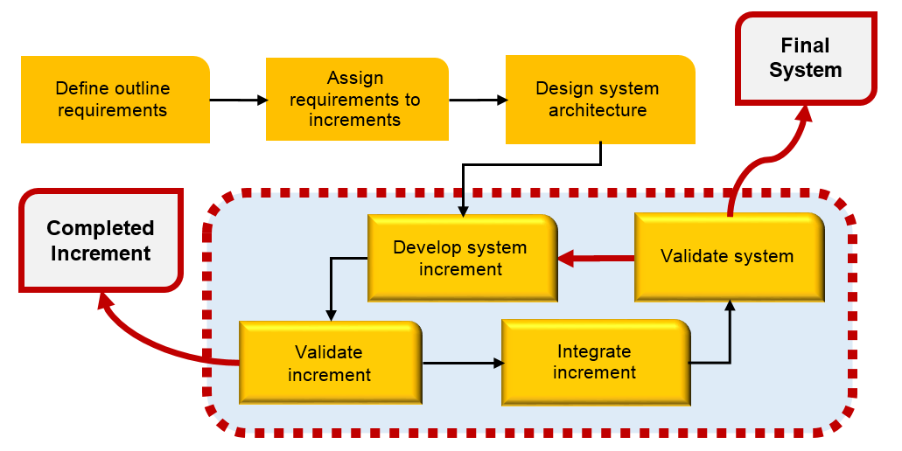
Figure: Incremental Delivery Process Model

2.2 Development Tools
• Eclipse
• ADT Plugin for Eclipse
• Tesseract-ocr
• Microsoft translator API
• Google Maps API
• SQLite
• JSON

2.3 Hardware and Material Resources
• Laptops
-- ASUS K43E
Processor: Intel(R) Core(TM) i5-2410M CPU @ 2.30GHz
Memory: 6.00 GB
Graphics: Intel(R) HD Graphics 3000
Operating System: Window 7 Home Basic

-- Dell Inspiron M4010
Processor: AMD Athlon(tm) ⅡP360 Dual-Core Processor @ 2.30 GHz
Memory: 6.00 GB
Graphics: ATI Mobility Radeon HD 5430
Operating System: Windows 7 Ultimate

• Internet
• Mobile phone: Android Operating System
-- Samsung GT-I9100G
CPU: ARMv7 Processor rev 3 (v7I) Dual-core @ 1.2 GHz
Memory: 1.97 GB
Operating System: Android OS version 4.0.4

• Repository: GitHub
Chapter Three | Management Procedures
3.1 Project Team Structure
Participants | Activities
Yirui Wang  Ruijuan Liu | Feasibility Study
Yirui Wang  Ruijuan Liu | Project Proposal
Yirui Wang  Ruijuan Liu | Project Requirements
Yirui Wang  Ruijuan Liu | Project Plan
Yirui Wang  Ruijuan Liu | Software Architectural Design
Yirui Wang  Ruijuan Liu | Software Architectural Design
Yirui Wang  Ruijuan Liu | Implementation
Yirui Wang  Ruijuan Liu | Testing
Yirui Wang  Ruijuan Liu | Review

3.2 Monitoring and Controlling Mechanisms
3.2.1 Software Development Models
3.2.2 Project Meeting
Participants | Roles
Yirui Wang | Development team member
Ruijuan Liu | Development team member
Yun Rim Park | Project advisor

Chapter Four | Quality Planning
4.1 Quality Standard
• ISO 29110 for Very Small Entity (VSE)
ISO 29110 is a software processes and guidelines for very small entities. A very small entity is mean an enterprise, organization, department or project having up to 25 people. The guide are based on subsets of appropriate standards elements, referred to as VSE profiles. The purpose of a VSE profile is to define a subset of ISO/IEC standards relevant to the VSE.

4.1.1 Basic Profile Guide Processes
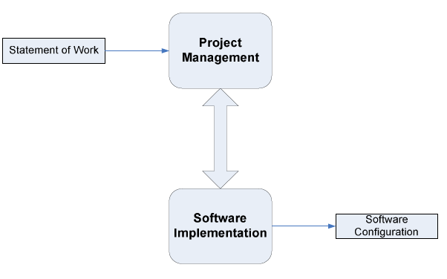

Figure: Basic Profile Guide Process

Project Management (PM) process uses the customer’s statement of work to elaborate the project plan. The PM project assessment and control tasks compare the project progress against the project plan and actions are taken to eliminate deviations or incorporate changes to the project plan. The PM project closure activity delivers the software configuration, produced by SI, and gets the customer’s acceptance to formalize the end of the project. A project repository is established to save the work products and to control its versions during the project.
The execution of the Software Implementation (SI) process is driven by the project plan. SI process starts with an initiation activity of the project plan review. Project plan will guide the execution of the software requirements analysis, software architectural and detailed design, software construction, and software integration and test, and product delivery activities

4.1.2 Project Management Process
The purpose of the project management process is to establish and carry out in a systematic way the tasks of the software implementation project, which allows complying with the project’s objectives in the expected quality, time and cost.
Selected processes
4.1.2.1 Project planning process
4.1.2.2 Project plan execution process
4.1.2.3 Project assessment and control process
4.1.2.4 Project closure process

4.1.3 Software Implementation Process
The purpose of the software implementation process is the systematic performance of the analysis, design, construction, integration and tests activities for new or modified software products according to the specified requirement.
Selected processes
4.1.3.1 Software implementation initiation process
4.1.3.2 Software requirement analysis process
4.1.3.3 Software architectural and detailed design process
4.1.3.4 Software construction process
4.1.3.5 Software integration and test process
4.1.3.6 Software delivery process

4.2 Reviews/Responsibility

Stage Exit Review
No. | Stage | Review Item | Responsibility
1 | Requirement gathering | Project Proposal | Yirui Wang, Ruijuan Liu, Yun Rim Park
2 | Project Planning | Project Plan | Yirui Wang, Ruijuan Liu, Yun Rim Park
3 | Requirement Analysis and Specification | Software Requirement Specification | Yirui Wang, Ruijuan Liu, Yun Rim Park
4 | Architecture and Detailed Design | Software Design Document | Yirui Wang, Ruijuan Liu, Yun Rim Park
5 | Software Implementation | Code | Yirui Wang, Ruijuan Liu, Yun Rim Park
6 | Software Testing | Software Testing Documents | Yirui Wang, Ruijuan Liu, Yun Rim Park
7 | Project Monitoring and Control | Traceability Record | Yirui Wang, Ruijuan Liu, Yun Rim Park

4.3 Testing

Stage Exit Review
No. | Test | Verification | Responsibility
1 | Unit Testing | Yirui Wang, Ruijuan Liu, Yun Rim Park | Yirui Wang, Ruijuan Liu, Yun Rim Park
2 | System Testing | Yirui Wang, Ruijuan Liu, Yun Rim Park | Yirui Wang, Ruijuan Liu, Yun Rim Park
3 | Acceptance Testing | Yirui Wang, Ruijuan Liu, Yun Rim Park | Yirui Wang, Ruijuan Liu, Yun Rim Park

4.4 Quality Factors

No. | User Requirement Specification | Related Quality Factor
1 | Users can scan Chinese words and Location names by using built-in camera. | Correctness, Integrity, Reliability, Testability, Usability, Efficiency
2 | Users can view the explanation (i.e. meaning, pronunciation) of the scanned word in English. | Correctness, Integrity, Reliability, Testability, Usability, Efficiency
3 | Users can select Text-to-Speech to get the Chinese pronunciation of the word. | Correctness, Integrity, Reliability, Testability, Usability, Efficiency
4 | Users can lock/unlock the screen which displays the text of the scanned word. (When locked, the scanning function will be disabled temporarily and the screen will keep the scanned image on display.) | Correctness, Integrity, Reliability, Testability, Usability, Efficiency
5 | Users can view the Location on the map if the scanned word is the name of a Location. | Correctness, Integrity, Reliability, Testability, Usability, Efficiency
6 | Users can view all Locations from their own Favorites on the map. | Correctness, Integrity, Reliability, Testability
7 | Users can view the map that shows the route from the current position to a Location stored in Favorites. | Correctness, Integrity, Reliability, Testability, Usability, Efficiency
8 | Users can view the map that shows the route from the current position to the Location whose name is scanned. | Correctness, Integrity, Reliability, Testability, Usability, Efficiency
9 | Users can add the scanned Location with its name, pictures, geometry information (i.e. latitude and longitude), and descriptions into their Favorites. | Correctness, Integrity, Reliability, Testability, Usability, Efficiency
10 | Users can delete a Location from their own Favorites. | Correctness, Integrity, Reliability, Testability
11 | Users can view the Location information with name, pictures, geometry information (i.e. latitude and longitude) and descriptions in their Favorites. | Correctness, Integrity, Reliability, Testability, Usability, Efficiency
12 | Users can sort the Locations in Favorites by district name. | Correctness, Integrity, Reliability, Testability, Usability, Efficiency
13 | Users can sort the Locations in Favorites by date they are added. | Correctness, Integrity, Reliability, Testability, Usability, Efficiency
14 | Users can search Locations by keyword in their Favorites. | Correctness, Integrity, Reliability, Testability, Usability, Efficiency
15 | Users can select Text-To-Speech to get the pronunciation of the Location name in their Favorites. | Correctness, Integrity, Reliability, Testability, Usability, Efficiency
16 | Users can add the scanned words into their own Word book. | Correctness, Integrity, Reliability, Testability, Usability, Efficiency
17 | Users can delete a word from their own Word book. | Correctness, Integrity, Reliability, Testability
18 | Users can view the Chinese words and related information in their own Word book. | Correctness, Integrity, Reliability, Testability, Usability, Efficiency
19 | Users can sort the words in their Word book by date when they are added. | Correctness, Integrity, Reliability, Testability, Usability, Efficiency
20 | Users can sort the words in their Word book alphabetically. | Correctness, Integrity, Reliability, Testability, Usability, Efficiency
21 | Users can search Chinese words in the Word book by their meaning in English. | Correctness, Integrity, Reliability, Testability, Usability, Efficiency
22 | Users can select Text-To-Speech to get the pronunciation of a Chinese word in their Word book. | Correctness, Integrity, Reliability, Testability, Usability, Efficiency

Chapter Five | Schedule and Milestones
5.1 Project Schedule
Feature #1 Translation system
Feature #2 Map system
Feature #3 Favorites system

Chapter Six | Software Configuration Management
6.1 Software Configuration Management
Software Configuration Management can coordinate the software management, which can minimize the confusion in the development. It is a set of activities designed to control changes by identifying the parts of the development that is likely to be changed, establishing relationships among them, defining mechanisms for managing different versions of them, controlling the changes imposed, and auditing and reporting on the changes made. In a word, Software Configuration Management is a methodology to control and manage a software development with its configuration. It can determine what to change and who to be responsible for the change when something goes wrong.

6.2 Filename Format
For the filename format that we use for all project documents is:
Scan in Travel_ [Document name] _V [Version].file type

6.3 Change Management
Change Management manages all the changes in the software development of the project. All the change requests will be recorded in the Change Request Document. We use the strategy for change management as following steps:
- Analyzing the change.
- Designing the change plan.
- Requesting for the change.
- Approving the change request by project advisor.
- Implementing the change as the approved change request.

6.4 Software Configuration Item Table
No. | Item | Filename | File Type | Owner | Path | Baseline Version
1 | Project Proposal | Scan in Travel_Proposal_V 1.1 | .doc | Yirui Wang  Ruijuan Liu | Scan in Travel /Proposal | 1.1

